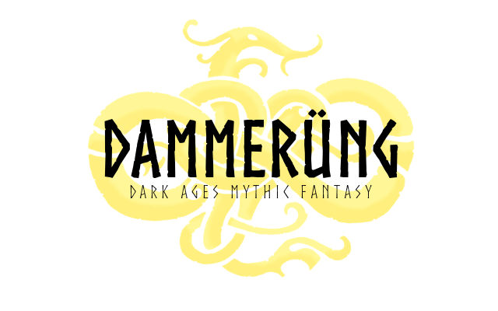

Name: | Phone:
Booth Name (For the schedule): | Business Name (If applicable):
Highlight all that apply:
Crafts Demonstration Activity

Your Specialty (i.e. clothing, archery, tarot cards): | Do you plan to Demonstrate?

Please describe your craft, demonstration or activity, up to and including a description of your booth and or a brief list of your salable goods.

Regular Performance of demonstrations will result in a ticketing discount or compensation, the rate of which depends on the activity and service provided.

Please submit this file to our Casting Director at Sjstone@Perthoproductions.com

